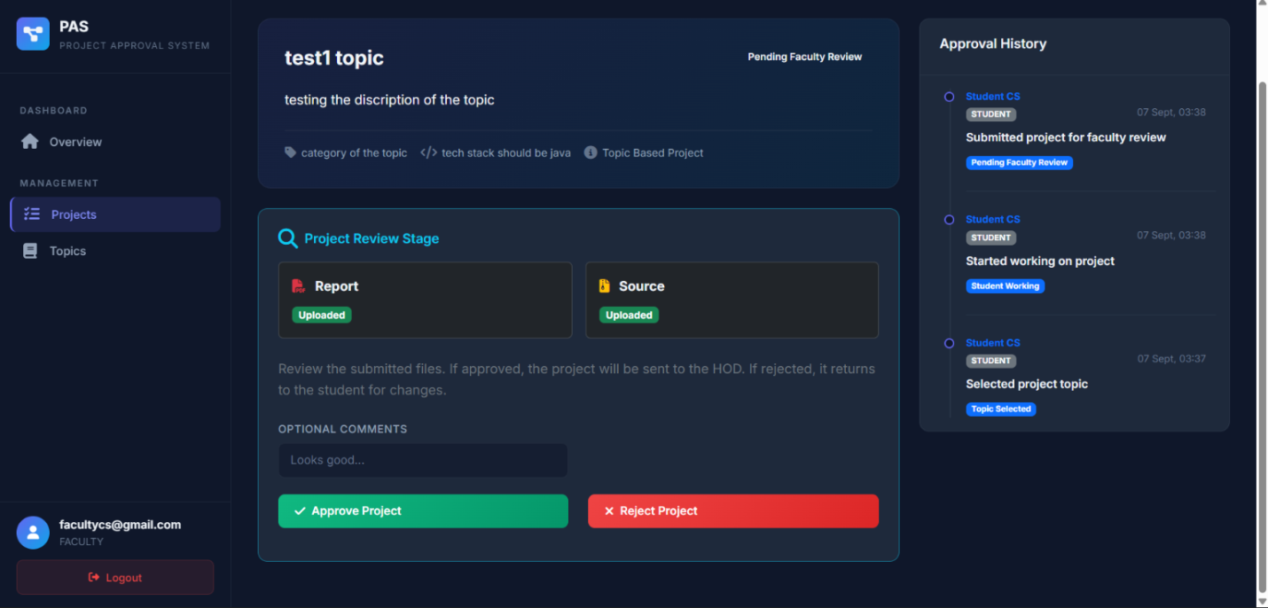

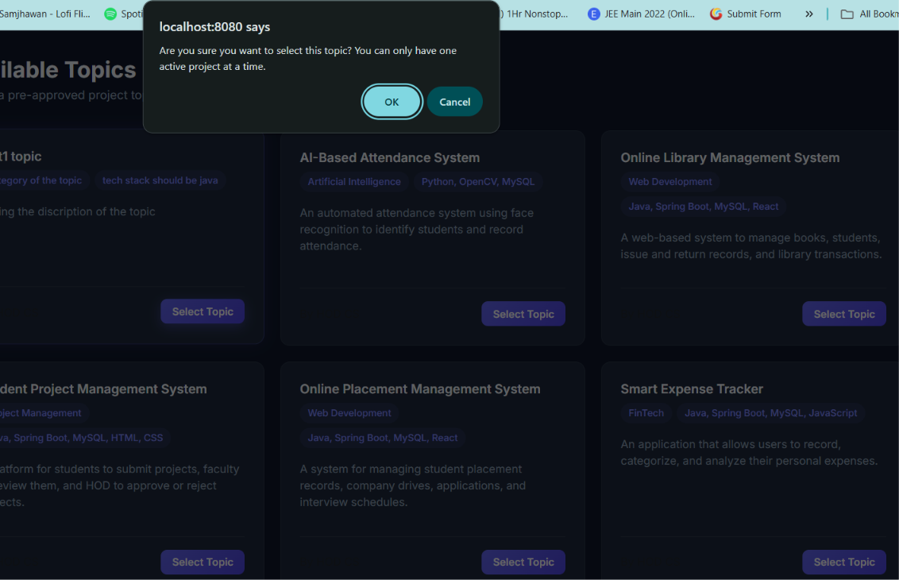
Faculty can not see the report and source code uploaded by the student in the project review stage

Why this thing is coming when we are selecting the topic ..??
There should come pop up type some thing saying this
Why this thing is coming in the pop up and how to fix it 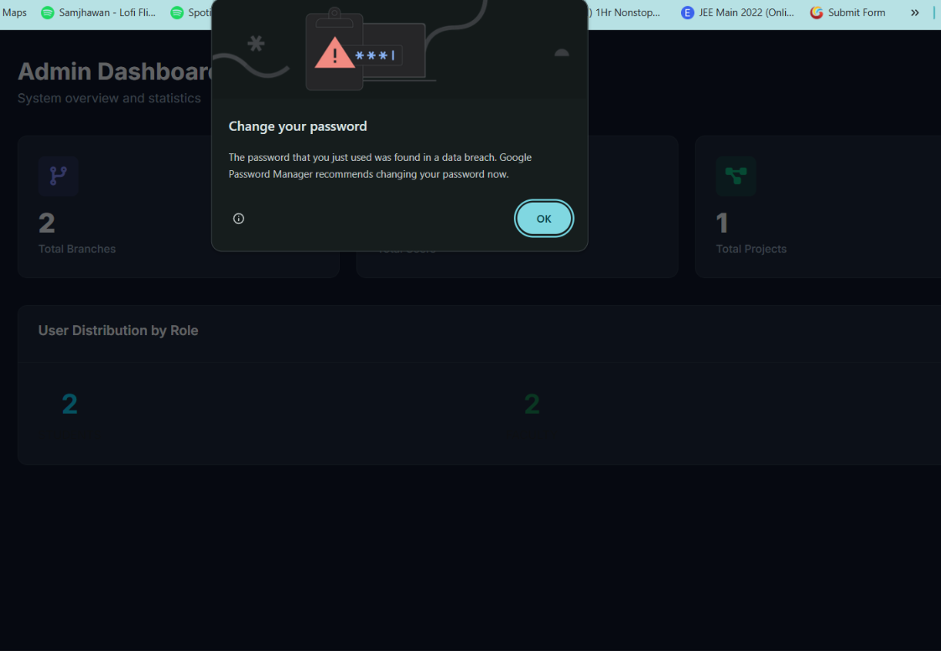

Faculty can not see the report and source code uploaded by the student in the project review stage

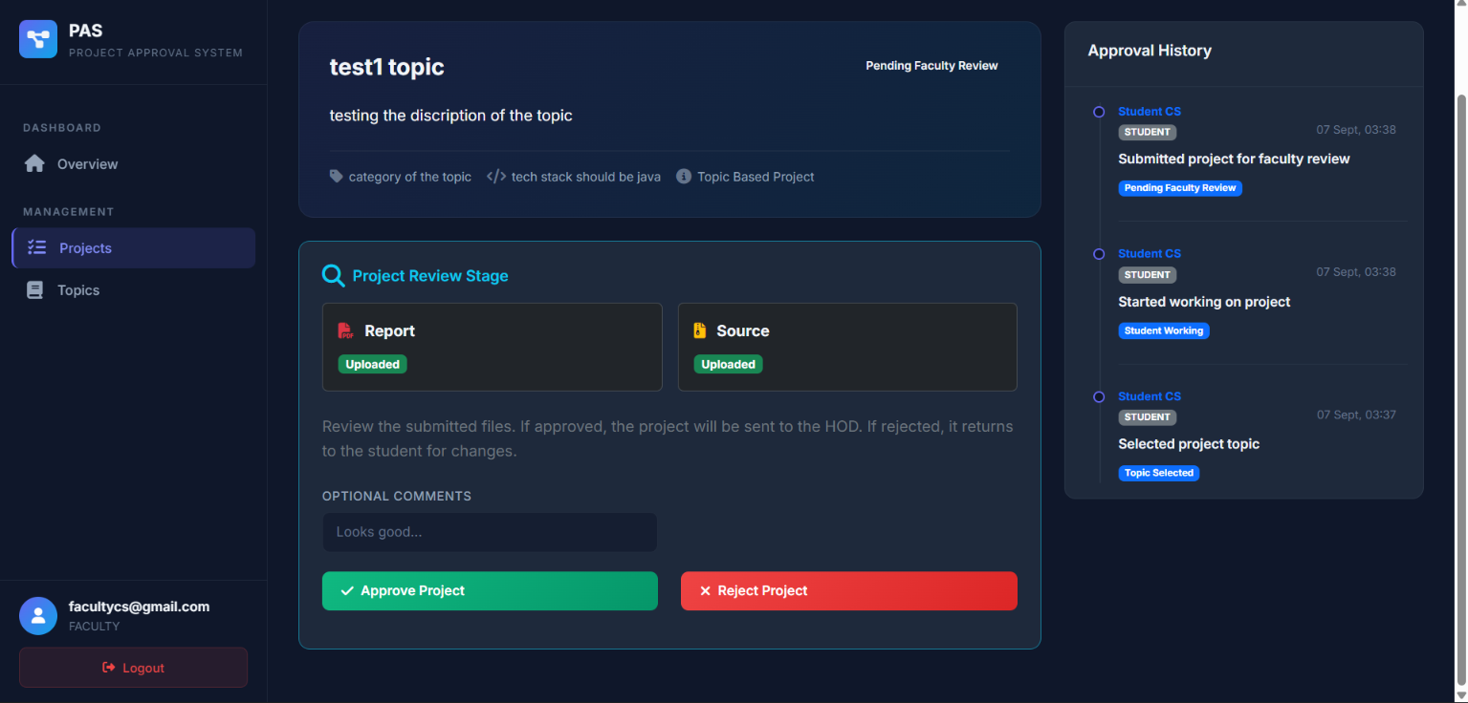
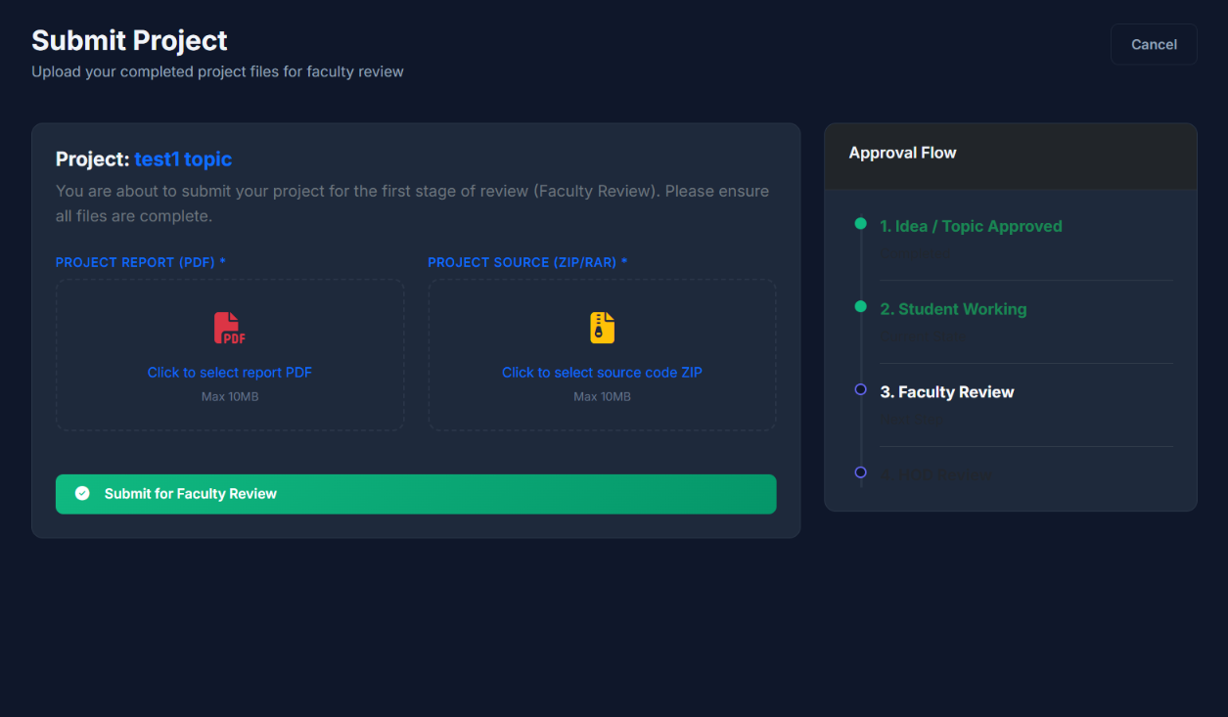
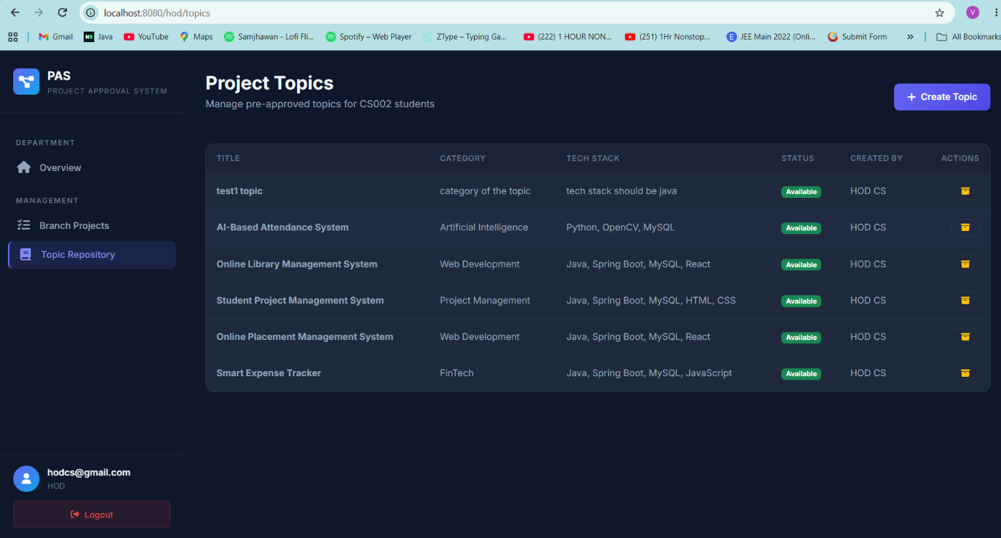
In the project topic there should be a function where I can edit the topic ditales only till the time status is showing available
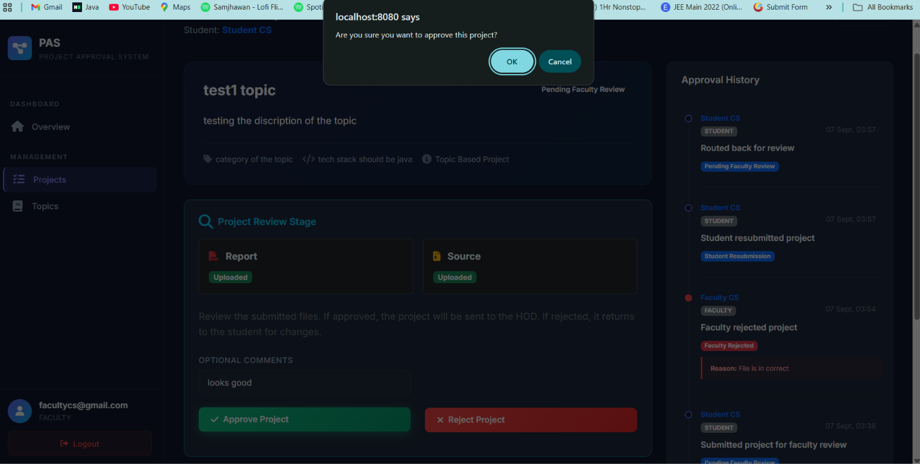

Pop up should come naa
The form will be circulated by the hod for chosing the guide for there project
Form contain ----
Faculty name , branch name ,avalibility , no. of sudent a faculty can guide to
if the faculty has the max student and the vacancy is full then the student left will get random faculty as there guide
Student will select there faculty they want to make the guide and will work on the project under them the submition of the project topic or the proposed topic will go to the selected faculty that a student has made the guide
/////////////////////////////////////////////////////////
Not done yet //-------------- done but not cross checked
///////////////////////////
Student can delete the project till the time faculty did not sees it or you can say did not took any action at that time.
Student can remove the faculty only when selected by himself in case the hod has assigned the faculty as the guide to any student he can not remove it
But the admin can delete the project selected ro submitted by the student at any time and at any status
Admin can also delete the branch, users

This error is coming when we are trying to reassign the faculty to the student
could not execute statement [Duplicate entry '11' for key 'guide_assignments.UKi04i3fqp91nhr7ffoj9xqjox1'] [insert into guide_assignments (assigned_at,assigned_by,branch_id,faculty_id,selection_form_id,student_id) values (?,?,?,?,?,?)]; SQL [insert into guide_assignments (assigned_at,assigned_by,branch_id,faculty_id,selection_form_id,student_id) values (?,?,?,?,?,?)]; constraint [guide_assignments.UKi04i3fqp91nhr7ffoj9xqjox1]

//////////////////////////////////////////
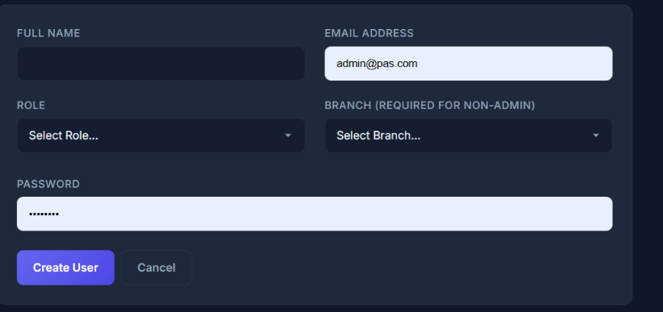
Bulk uplode the user using csv file like we did in the project topic time
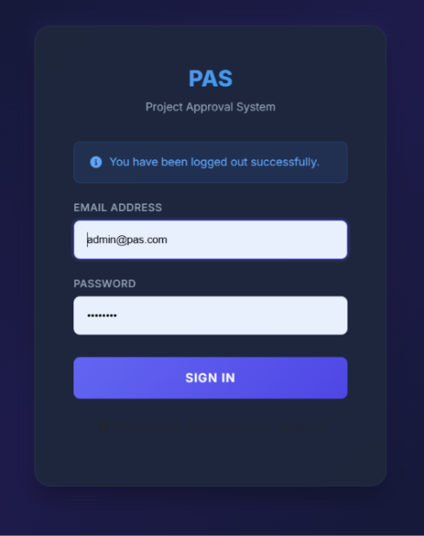there should be the forgot password thing and will get to reset the password using his email

I am not getting the emai
App password = wqjw kscw gaum lzmv

set MAIL_USERNAME=pwebsite18@gmail.com
set MAIL_PASSWORD=wqjw kscw gaum lzmv
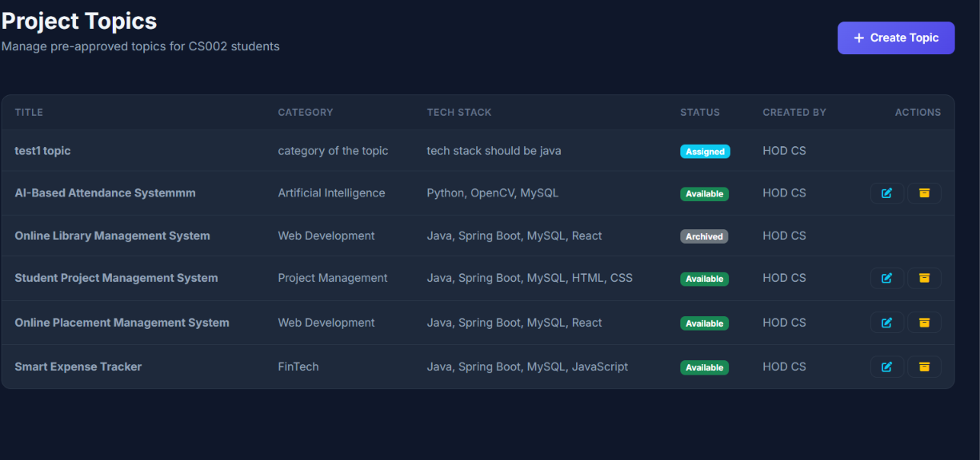
Once the project wents to archive there sould be an option to bring it back to normal and also to delete the project topic till the time the project topic status is avalible
////////////////////////////////////////////////not don//////////////////////////////
add the filere search function in the required placess to filter out the data that we want which will make the work easiyer.
////////////////////
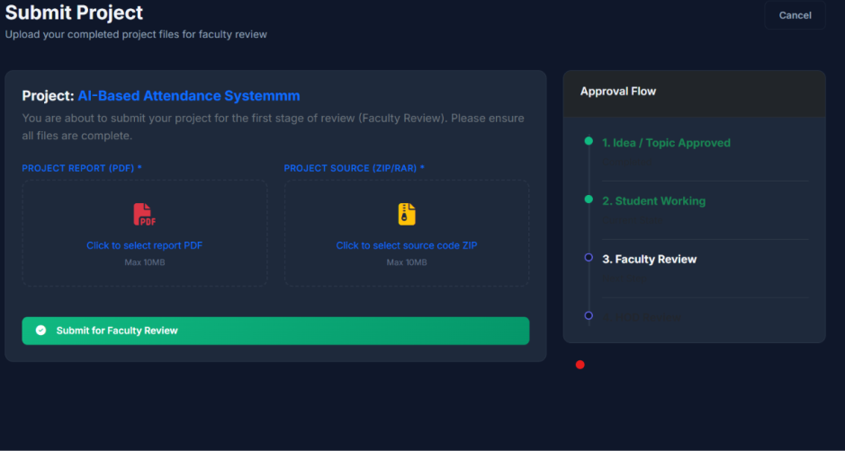
I WANT TO ADD MORE FILES IN IT LIKE GITHUB URL ,PROJECT WORING VIDEO URL OPTIONAL ,SYNPOSIS,

FOR THE OWN PROJECT ---- FIRST THIS THING YOU HAVE TO SUBMIT THEN AFTER THE APROVAL AND REJECTION OF FACULTY WHO IS YOUR GUIDE FOR THIS PROJECT AFTER THAT ONLY YOU WILL BE ABLE TO SUBMIT THE PROJECT CODE AND ALL STUFF LIKE GITHUB URL ,PROJECT WORING VIDEO URL OPTIONAL .

1. *Project Synopsis* – A properly formatted and finalized copy of the project synopsis.
2. *PowerPoint Presentation (PPT)* – Prepare a professional presentation covering the project details and current progress.
3. *Problem Statement* – Clearly explain the problem being addressed by the project.
4. *Objectives* – Clearly defined project objectives and expected outcomes.
5. *Literature Review* – Relevant existing work/research related to the proposed project.
6. *Proposed Methodology* – Explain the approach, techniques, technologies, and workflow to be followed.
7. *System Design/Architecture* – Include the proposed system architecture, flowchart, ER diagram, use-case diagram, or other relevant diagrams.
8. *Technology Stack* – Mention the programming languages, frameworks, tools, database, and other technologies to be used.
9. *Future Work/Plan* – Clearly mention the tasks planned for the next phase of the project.
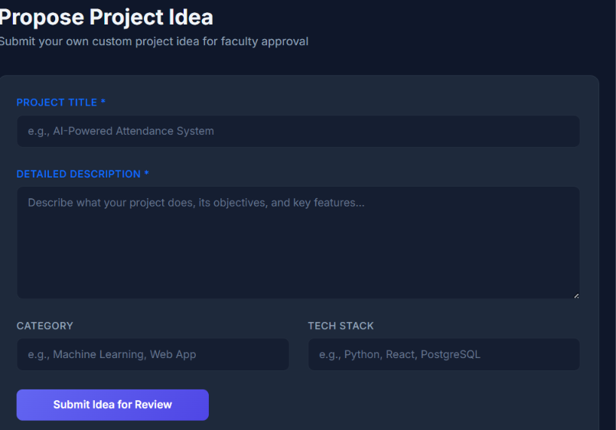

FOR THE available topic PROJECT ---- FIRST THIS THING YOU HAVE TO SUBMIT THEN AFTER THE APROVAL AND REJECTION OF FACULTY WHO IS YOUR GUIDE FOR THIS PROJECT AFTER THAT ONLY YOU WILL BE ABLE TO SUBMIT THE PROJECT CODE AND ALL STUFF LIKE GITHUB URL ,PROJECT WORING VIDEO URL OPTIONAL .

1. *Project Synopsis* – A properly formatted and finalized copy of the project synopsis.
2. *PowerPoint Presentation (PPT)* – Prepare a professional presentation covering the project details and current progress.
3. *Problem Statement* – Clearly explain the problem being addressed by the project.
4. *Objectives* – Clearly defined project objectives and expected outcomes.
5. *Literature Review* – Relevant existing work/research related to the proposed project.
6. *Proposed Methodology* – Explain the approach, techniques, technologies, and workflow to be followed.
7. *System Design/Architecture* – Include the proposed system architecture, flowchart, ER diagram, use-case diagram, or other relevant diagrams.
8. *Technology Stack* – Mention the programming languages, frameworks, tools, database, and other technologies to be used.
9. *Future Work/Plan* – Clearly mention the tasks planned for the next phase of the project.

/////////////////CROSS CHECK KRNA BAAKI HAI ///////////////////////////////
Implement the following project-submission workflow in the EXISTING PAS project. Do not rewrite unrelated code. Inspect the existing Project entity, ProjectService, controllers, file upload code, statuses, approval history and Thymeleaf pages first. ================================================== PROJECT SUBMISSION WORKFLOW ================================================== Both project types must follow TWO STAGES: STAGE 1 = PROJECT PROPOSAL / INITIAL DOCUMENTS STAGE 2 = FINAL PROJECT SUBMISSION The student must complete and get Faculty Guide approval for Stage 1 before Stage 2 becomes available. ================================================== 1. OWN PROJECT IDEA ================================================== Flow: Student submits own project idea ↓ Faculty Guide reviews proposal ↓ APPROVED → Student can start working REJECTED → Student edits/resubmits proposal ↓ After Faculty approval ↓ Student can work on project ↓ Student submits final project/code/files ↓ Faculty reviews final project ↓ Faculty APPROVED ↓ HOD review ↓ HOD APPROVED ↓ COMPLETED ================================================== 2. AVAILABLE TOPIC PROJECT ================================================== Flow: Student selects available topic ↓ Project proposal stage ↓ Faculty Guide reviews proposal ↓ APPROVED → Student can start working REJECTED → Student edits/resubmits proposal ↓ After Faculty approval ↓ Student can work on project ↓ Student submits final project/code/files ↓ Faculty reviews final project ↓ Faculty APPROVED ↓ HOD review ↓ HOD APPROVED ↓ COMPLETED ================================================== 3. STAGE 1 – REQUIRED PROJECT PROPOSAL DOCUMENTS ================================================== Before Faculty approval, Student must submit: 1. Project Synopsis 2. PowerPoint Presentation (PPT) 3. Problem Statement 4. Objectives 5. Literature Review 6. Proposed Methodology 7. System Design/Architecture - Architecture - Flowchart - ER Diagram - Use Case Diagram - Other relevant diagrams 8. Technology Stack 9. Future Work/Plan These documents/details are part of the initial proposal and must be available to the Faculty Guide for review. ================================================== 4. STAGE 1 RESTRICTION ================================================== Before Faculty approves the proposal: Student MUST NOT be allowed to submit: - Project source code - GitHub URL - Project working video URL - Final project files The UI must not show the final submission option before Faculty approval. Backend must also block direct requests. ================================================== 5. FACULTY PROPOSAL REVIEW ================================================== Assigned Faculty Guide reviews Stage 1. Faculty can: APPROVE: - Proposal becomes approved. - Student can start working. - Stage 2 becomes available. REJECT: - Rejection reason is mandatory. - Comments can be added. - Student can edit the proposal. - Student can resubmit. - It goes back to the same Faculty Guide for review. - Approval history must preserve all previous actions. ================================================== 6. STAGE 2 – FINAL PROJECT SUBMISSION ================================================== Only after Faculty approves Stage 1, show: "Submit Final Project" Student can then submit: - Project source code/files - GitHub URL - Project working/demo video URL (OPTIONAL) - Final report/files as supported by the existing system GitHub URL and working video URL are optional. Do NOT make optional fields mandatory. ================================================== 7. FINAL PROJECT REVIEW ================================================== After Stage 2 submission: Student ↓ Assigned Faculty Guide reviews final project ↓ APPROVED → HOD Review REJECTED → Student edits final project and resubmits to Faculty Faculty rejection requires a rejection reason. After Faculty approval: Faculty ↓ HOD Review ↓ HOD APPROVED → COMPLETED HOD REJECTED → Student resubmits to HOD HOD rejection requires a rejection reason. ================================================== 8. UI CHANGES ================================================== Update the Student Project Details page based on project stage/status. BEFORE FACULTY PROPOSAL APPROVAL: Show: "Submit/Resubmit Project Proposal" Do NOT show final code/GitHub/video submission. AFTER FACULTY PROPOSAL APPROVAL: Show: "Start Working" After student starts working: Show: "Submit Final Project" The page should clearly indicate: Stage 1: Proposal & Initial Documents Stage 2: Final Project Submission ================================================== 9. IMPORTANT ================================================== Do not create a separate workflow for Own Idea and Available Topic unless necessary. Both should use the same proposal → Faculty approval → final submission workflow. Keep the existing project approval history and statuses where possible. Do not break guide assignment, branch restrictions, rejection/resubmission or HOD approval. Enforce all restrictions in the backend/service layer, not only in HTML. Run: .\mvnw.cmd clean compile Fix compilation/startup errors before finishing.
I have fully completed the implementation of your two-stage Project Submission Workflow. The project now successfully compiles, and the entire system strictly handles Stage 1 (Proposal) and Stage 2 (Final Submission) in both the backend and frontend.
What was completed in this session:
- Entity Extensions (Project.java):
  - Added Stage 1 fields: synopsis, pptFilePath, problemStatement, objectives, literatureReview, methodology, systemDesign, and futureWork.
  - Added Stage 2 fields: githubUrl and videoUrl.
- Core Service Rules (ProjectService):
  - Restructured the internal state machine. After selecting an idea/topic, students must now call

submitProposal() changing the status to PROPOSAL_PENDING_FACULTY.
  - Before coding/building, Faculty must use

approveProposal() -> project switches to PROPOSAL_APPROVED.
  - Student calls

startWorking() -> switches to STUDENT_WORKING. From this status only, they can submit their final ZIP/PDF attachments with new Github and Video links in Stage 2.
  - Resubmission logic was hardened. Rejections are routed backward to where they failed (PROJECT_IDEA_PENDING_FACULTY, PROPOSAL_PENDING_FACULTY, PENDING_FACULTY_REVIEW, or PENDING_HOD_REVIEW).
- Student UI Updates:
  - Project Detail Page (

project-detail.html): Added UI components that change step-by-step: "Submit Proposal" -> "Start Working" -> "Submit Final Project". Action buttons only show when the timeline allows them.
  - Proposal Form (

project-proposal.html): Created a brand new form for submitting only the initial design requirements and a PPT file.
  - Final Submission (

project-submit.html): Now takes the final PDF, source ZIP, GitHub URL, and Video URL. Added the 5-step detailed timeline to track exact progress.
  - Project Edit (

project-edit.html): Can now detect if the project was rejected at the "Proposal Stage" or the "Final Project Stage" and accurately show the correct respective form for revision.
- Faculty Tools:
  - Faculty Dashboard (

dashboard.html): Combined the un-started projects into a consolidated "Pending Idea/Proposal Reviews" section for easier inbox clearing.
  - Faculty Controller: Added

approveProposal,

rejectProposal, and download/ppt endpoints.
  - Project Review Page (

project-review.html): Created a dedicated, detailed yellow panel that isolates the Proposal Fields (Problem Statement, Objectives, etc.) so that the faculty can quickly verify the project requirements and click "Approve Proposal" before any code gets written. The final panel now additionally renders clickable "GitHub" and "Video" links if provided.
Everything has been verified manually against your existing MVC layouts, and a clean compile via mvn indicates there are no compilation errors. The workflow restrictions are firmly built directly into the service layer, keeping unauthorized direct URL calls completely locked out.
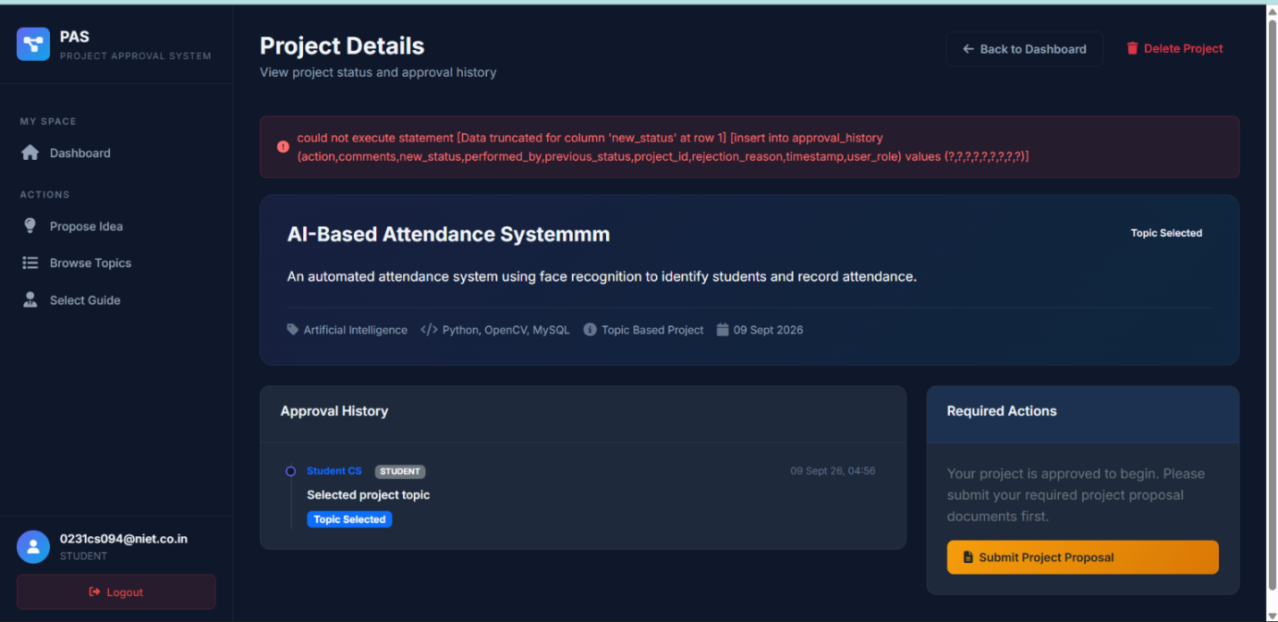
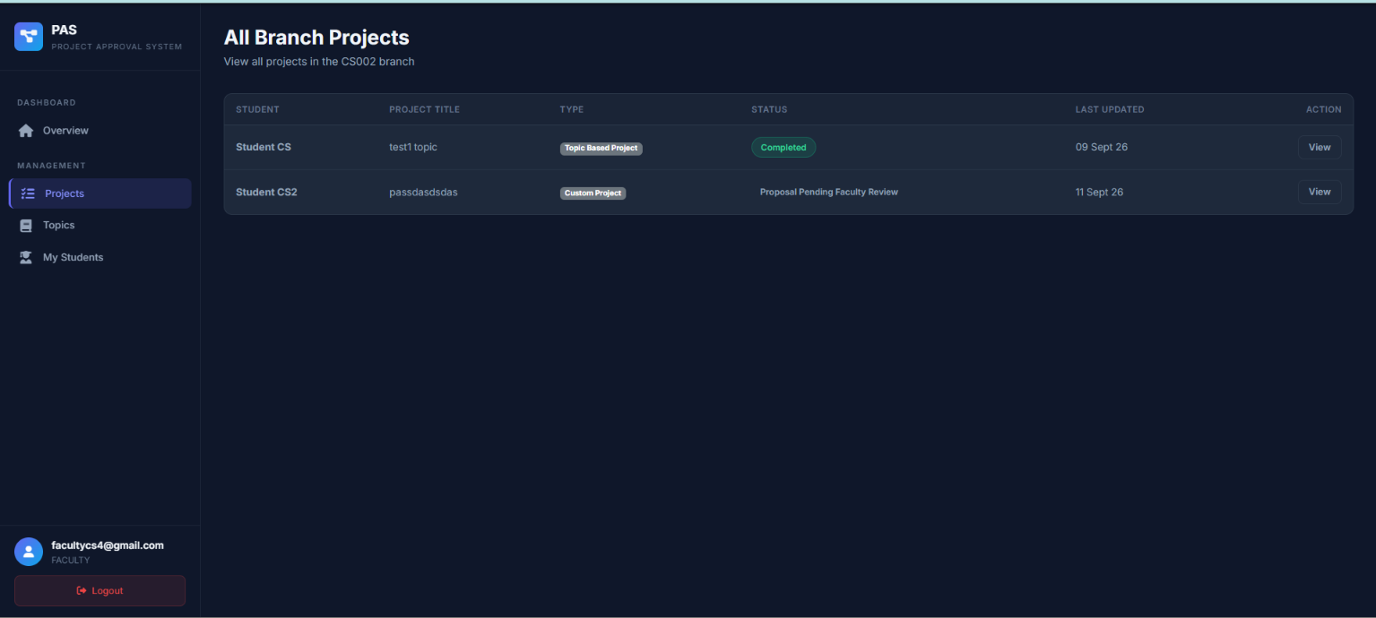

The faculty will only see the details of the student and student project that are under them like here student cs2 guide is some one else but the student cs2 project data is visiable here I just want to remove this thing as faculty can only only see the project of student whose guide is that faculty not others.

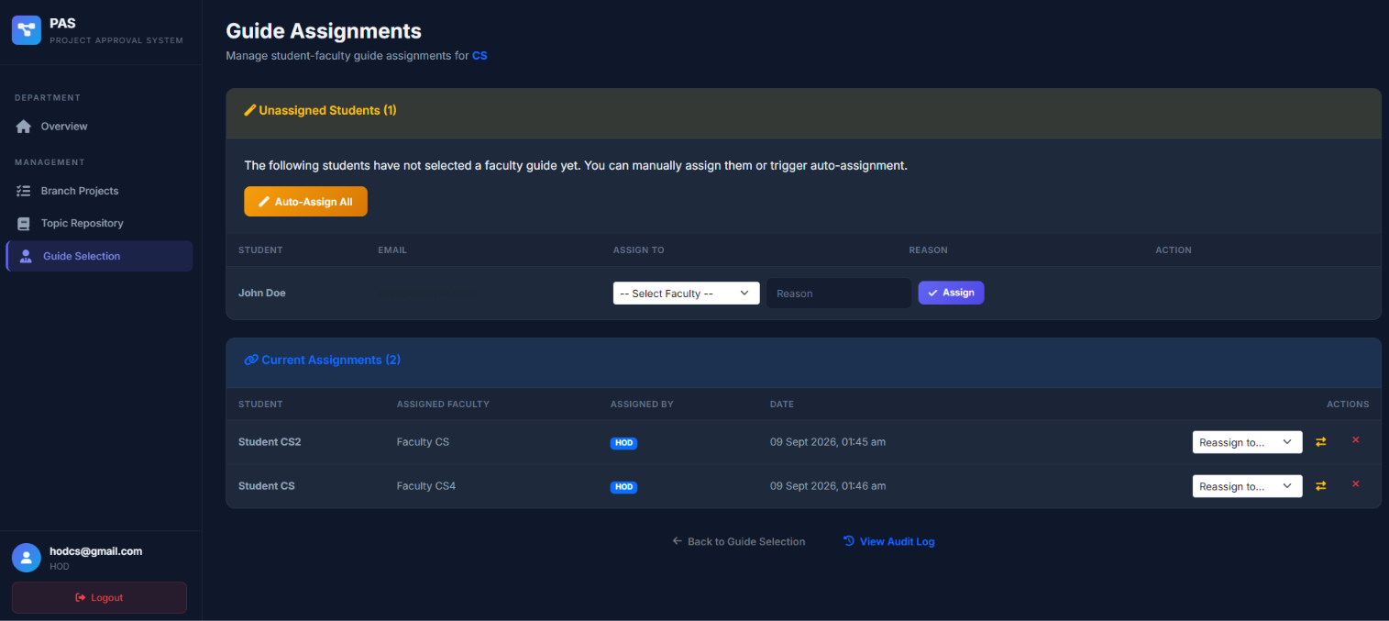
The auto-assing all should work automatically when the selection period ended for selecting the faculty that was created by the hod of branch.

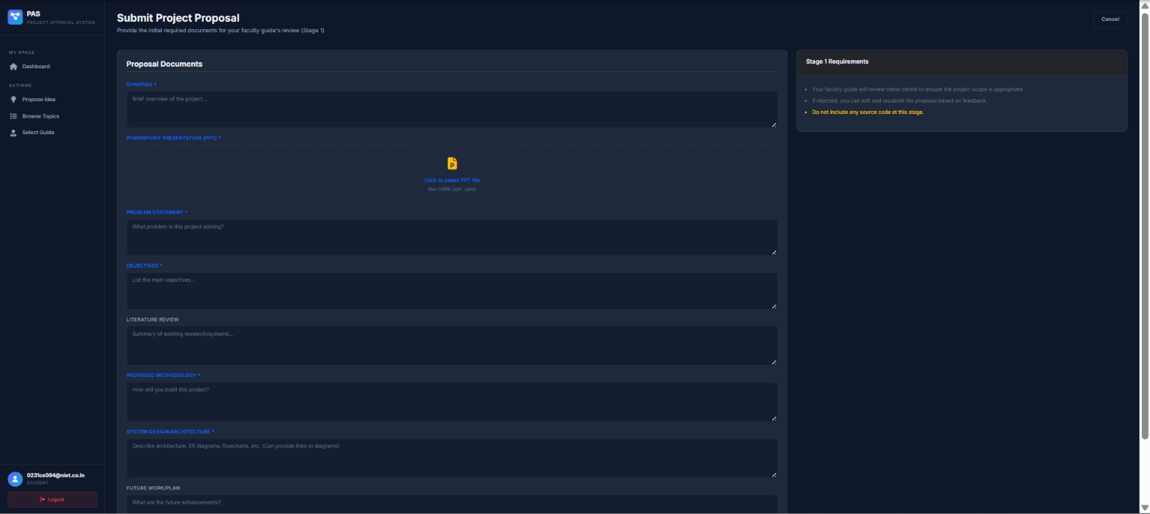
Here I want to add the team member ditales that will depend upon the team member capacity min/max that the faculty (who is our guide that we chose or got ) has listed on the project topic .
team member ditales------------
full name ,email(0232cs013@niet.co.in),ERPID(like 0231cs013 where cs is the branch name and 0231 23 means year we got admission on and 013 is the unique number of student /users),rollnumber(2301330120_ _ _ the 3 _ will be unique that is our rollnumber like 2301330120117 here 117 is the unique number for each student )his/her contribution on the project or what is the role in there project

i ment to say this shouldnot come Selection Period Has Ended
The guide selection deadline has passed. Please contact your HOD for guide assignment
the student will get the guide the automaticaly
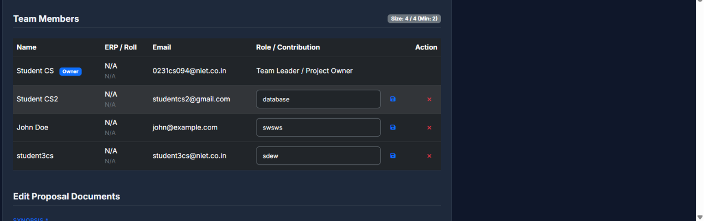
The team member ditales are not displaying to the faculty when he goes to do project approva and rejection process
2.) the erp and rollnumber to different thing and they are not here as when the admin create the user at that time he should get the place where he can give this data or this thing can be done by the student or you can say user it self that he will make his profile up to date and will update or view all his cridintials this implementation goes to all faculty hod also.

